MDHHS – MCIR Release Notes
Version 2024 – MCIR OLTP 2024 24.5.29 – RFC 237088 Release Date: 05/29/2024

Forecasting & Assessment – 4 Items
- Forecast and evaluate CVX 316 MenABCWY (Penbraya) (Ref # 2684)
History Screen:
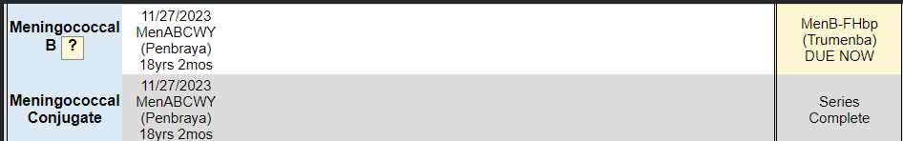
Status Screen:
Landscape Report:
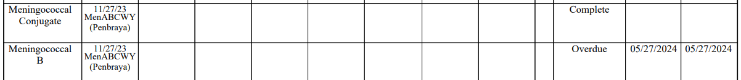

- Persons aged from 10 through 23 may receive MenABCWY (Penbraya) when MenABCWY and MenB are indicated at the same visit.
- The two brands of MenB vaccines are not interchangeable. The series, and booster doses when indicated, must be started, and completed with the same brand of vaccine.
- The MenB component of MenABCWY (Penbraya) is Trumenba. If Penbraya is administered, subsequent doses of MenB should be from the same manufacturer (Trumenba-Pfizer Inc). The following link is provided for additional guidance:
  - Use of the Pfizer Pentavalent Meningococcal Vaccine Among Persons Aged ≥10 Years: Recommendations of the Advisory Committee on Immunization Practices ― United States, 2023 | MMWR (cdc.gov)
- Disclaimer: The MCIR “Quick Look” for Meningococcal B is currently being revised and may not contain the most recent ACIP recommendations.
  - Please refer to the link below:
    - Meningococcal B Vaccine Recommendations by Age and Risk Factor (immunize.org)

- MenACWY dose given at ages 9 to under 10 years of age should forecast adolescent dose at age 11yrs (Ref# 2634)
Information Screen: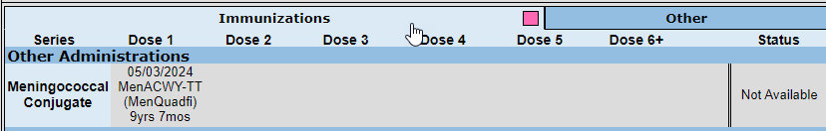
Please refer to the link below:
Meningococcal ACWY Archives | Immunize.org

- Unable to change Compromised Status for Tdap CVX 115 (Ref# 2830)
Update to Compromised Vaccine Status screen: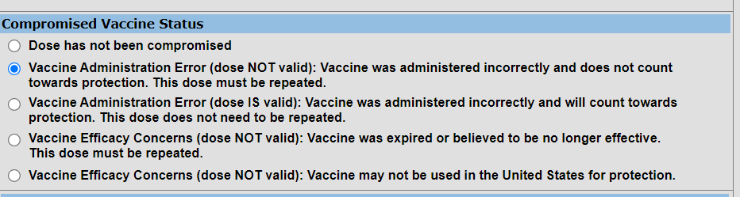
Update Accepted: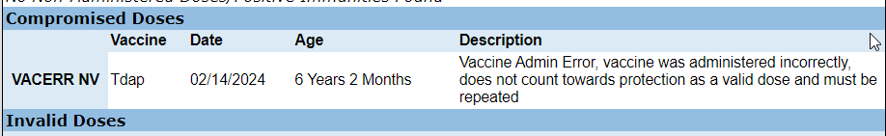

- No forecast reported for COVID-19 Moderna 25mg (Ref# 2935)
Information Screen:
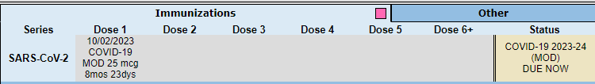
Status Screen:
Landscape Report:

General – 2 Item
- Change HL7 duplicate immunization acknowledgement code to AA (Ref# 2852)
- Enhance HL7 to provide Warning for incorrect funding eligibility codes (MIA-10) (Ref# 2601)

If you have questions or need assistance, please contact your Field Representative or
MCIR SOM Help Desk at MDHHS-MCIRHelp@michigan.gov.

