MDHHS – MCIR Release Notes
Version 2024 – MCIR OLTP 2024 24.6.12 – RFC 237997 Release Date: 06/12/2024

Forecasting & Assessment – 4 Items
- HPV 2nd dose accelerated date needs to display 1 month from dose 1, 2 months from dose 1 for recommended and overdue for 15 years of age and older. (Ref# 2972)
Information Screen: 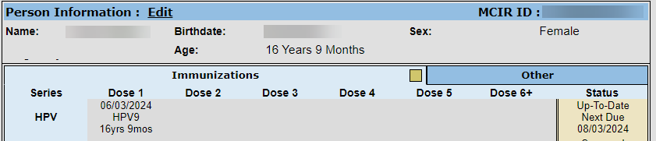
Status Screen:
Landscape Report: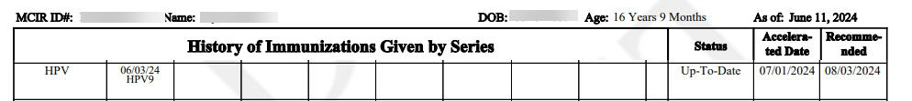
- Please refer to the link below:

- HPV Vaccine Schedule and Dosing | CDC

- Hep B Not Displaying on Status Screen School/Childcare Sites (Ref# 2971)
Information Screen:
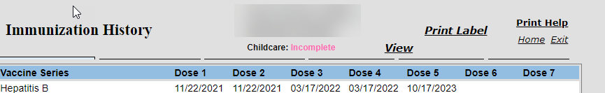
Status Screen:
- HepB doses not evaluated, HPV9/HIB does not appear in status for eligible individuals (Ref# 2954)
HPV: Information Screen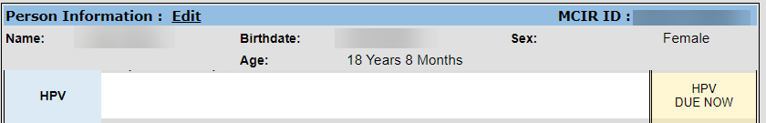
HPV: Status Screen
HPV: Landscape Report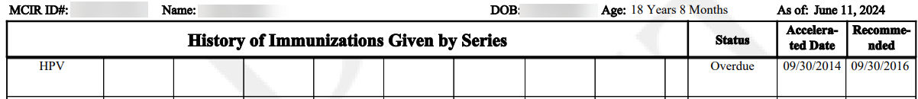
HIB: Information Screen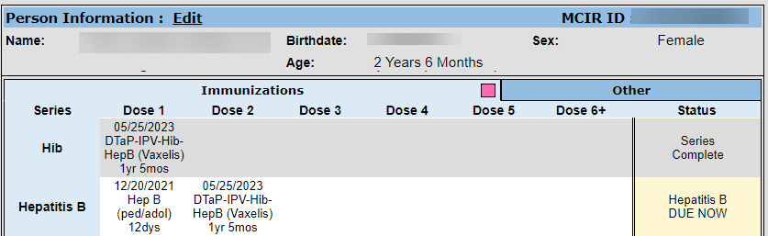
HIB: Status Screen
HIB: Landscape Report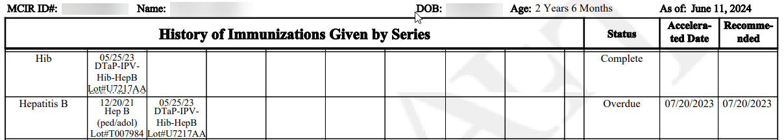

- COVID-19 - Forecast for 65 years and older 1 additional dose of any updated (23–24 Formula) COVID-19 vaccine at least 4 months after previous dose of updated (23–24 Formula) (Ref# 2973)
Information Screen: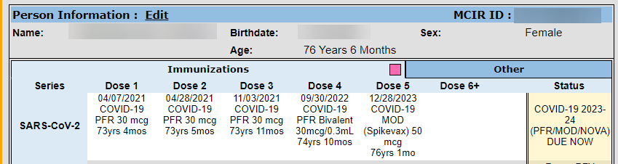
Status Screen
Please refer to the link below:
Clinical Guidance for COVID-19 Vaccination | CDC

If you have questions or need assistance, please contact your Field Representative or
MCIR SOM Help Desk at MDHHS-MCIRHelp@michigan.gov.

